**DATA1201: Introduction to Relational Database-22JANMNCO2**

**Tutor: Tigist Beshe**

**Database Design for a Shared Workspace**

**Group 2: Leader-Abdulgafar Malik (Student Id:** **424125)**

**Manpreet Kaur (Student Id:** **425695)**

**Shivam Verma (Student Id: 414384)**

**Jashanpreet Kaur Gill (Student Id:** **424077)**

**ERD Diagram**

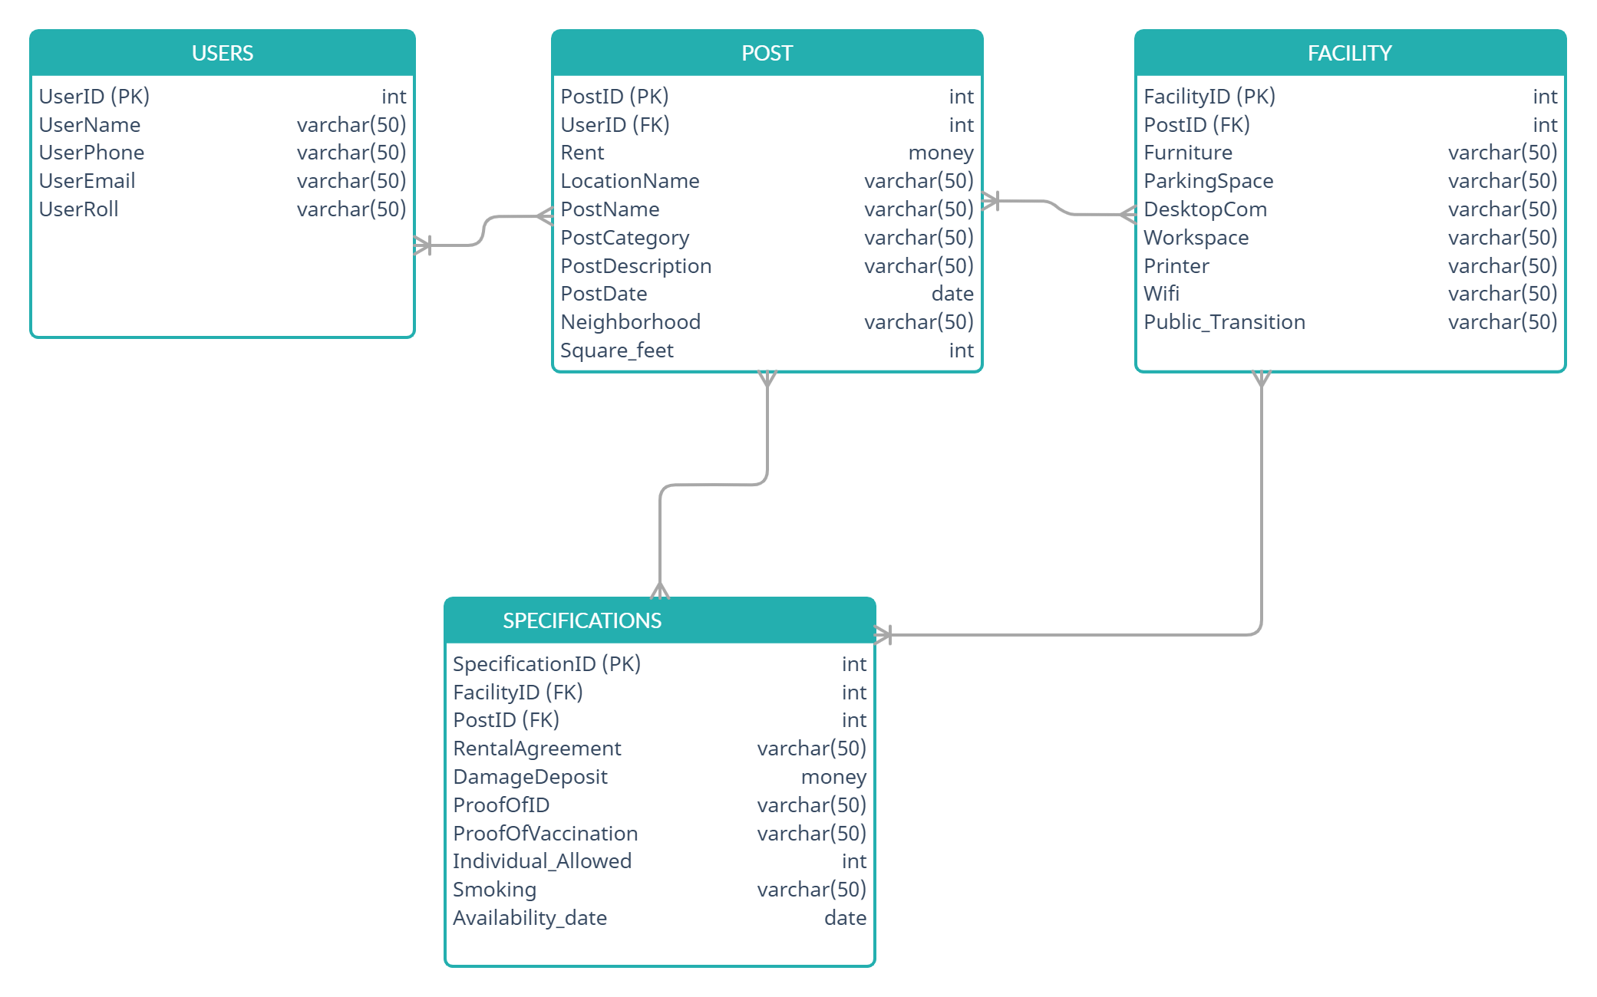

The ERD Diagram contains four tables.

* The first table is the Users table which consists of the information about the User whether an Owner or Coworker who wants to give their property or space for rent and who want to take that property or space on rent. This table contains **UserID** **(Primary Key), UserName, UserPhone**, **UserEmailID** and **UserRoll(Owner or Coworker).**
* The Second table is the POST table which tells which post belongs to which User(Owner) with the help of **Foreign Key** i.e., **UserID**. This table also contains **PostID (Primary Key)**, **Rent, LocationName, PostName, PostCategory, PostDescription. PostDate**, **Neighborhood and Square_feet.**
* The Third table is the FACILITY table which gives information regarding the Facilities available in the rental property linking to the post with the help of a **Foreign Key** named **PostID.** Additionally, this table contains **FacilityID** **(Primary Key)**, **Furniture, ParkingSpace, DesktopCom, Workspace, Printer, WiFi** and **Public_Transition.**
* The fourth Table is the RENTAL SPECIFICATIONS table that layouts the conditions which are covered in the **Rental Agreement** that the tenant must agree to it, **DamageDeposit** that the User(Owner) will be taking from the tenants(Coworker) as a security for the facilities provided according to the post (taking from the **FacilityID** and **PostID** which is the **Foreign Key**) provided to the lessee. It also contains **RentalSpecificationID, IDProof**, **ProofOfvaccination**. **Individual_Allowed, Smoking** and **Availability_date.**

|  |  |  |
| --- | --- | --- |
| **TABLE NAME** | **RELATIONSHIP** | **TABLE NAME** |
| Users | MANY TO MANY | Post |
| Post | MANY TO MANY | Facility |
| Post | MANY TO MANY | Rental Specifications |
| Facility | MANY TO MANY | Rental Specifications |

**Sample Table**





